
[Type here]

VOIP lab experiment#4 Configuring Zoiper

Installation and Repair of Telecommunications Equipment

Name of student:
Group Number:
Date:

[Type here]
The purpose of the lab is to demonstrate the ability of the students to configure the softphone Zoiper by assigning an extension created in lab#3.
- To start assigning an extension, you need to open the software.
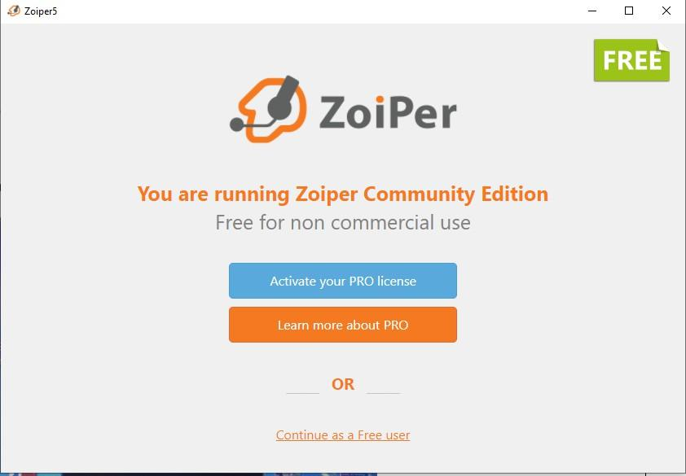
- Click on continue as a free user

- You want to assign an extension to the softphone. ONLY 1 Extension can be assigned to 1 softphone at a time.
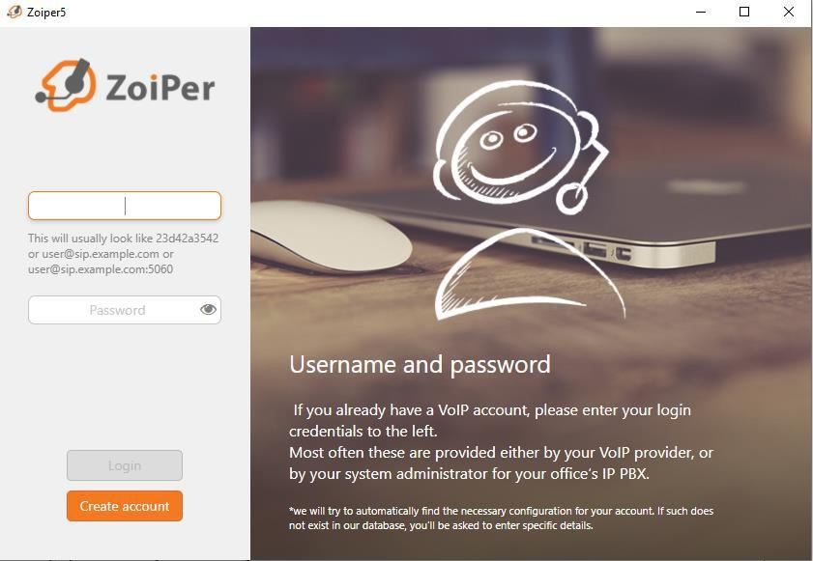
- In the first rectangle assign one of the 3 extensions you have created in lab#3. (1000, 2000 or 3000). In the 2nd rectangle enter the password of the extension: pec123

[Type here]
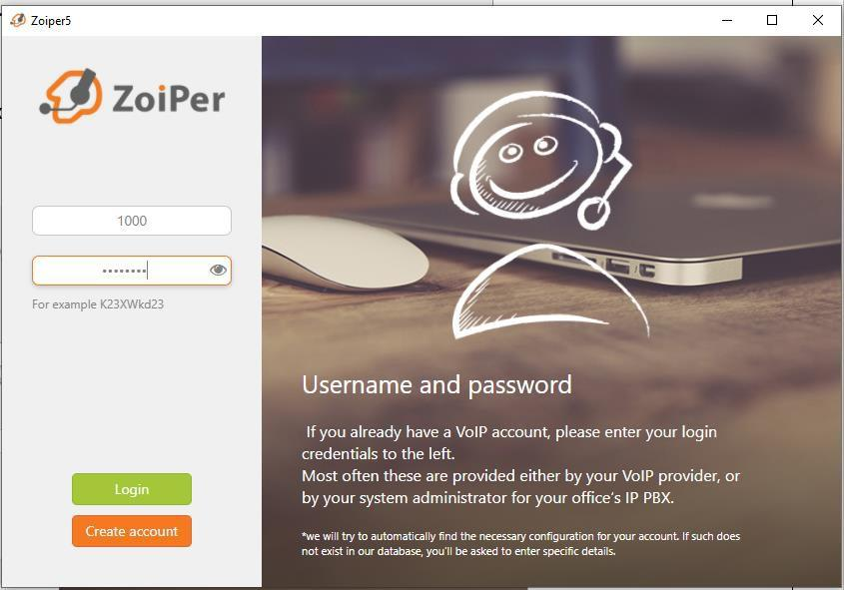

- The 2nd rectangle password is pec123, click on login
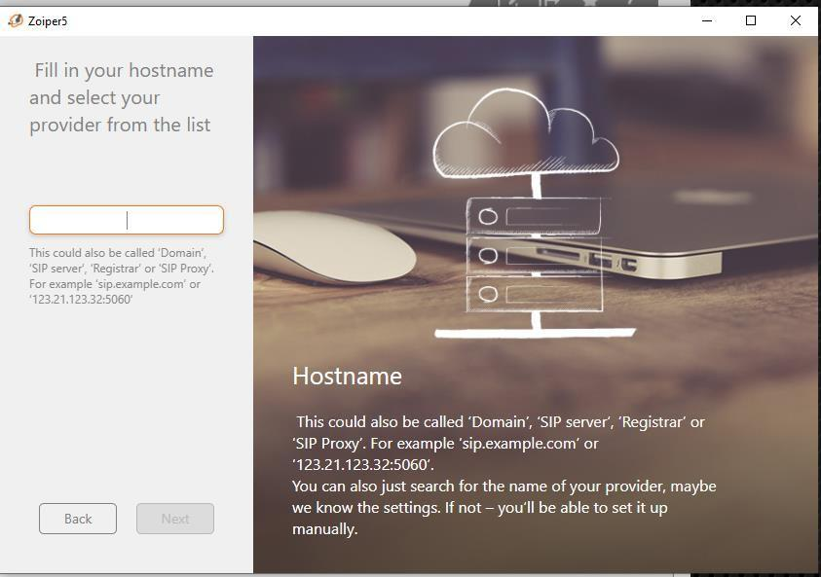
- In the rectangle, enter your PBX IP address, then click on Next

[Type here]
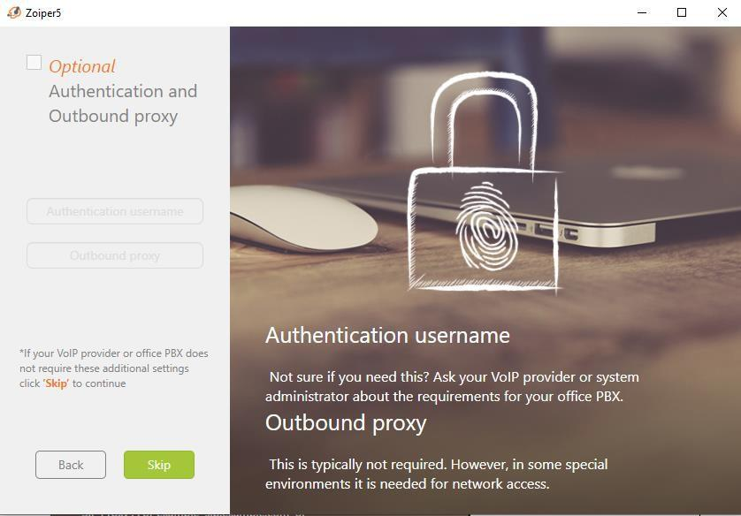
- Press skip

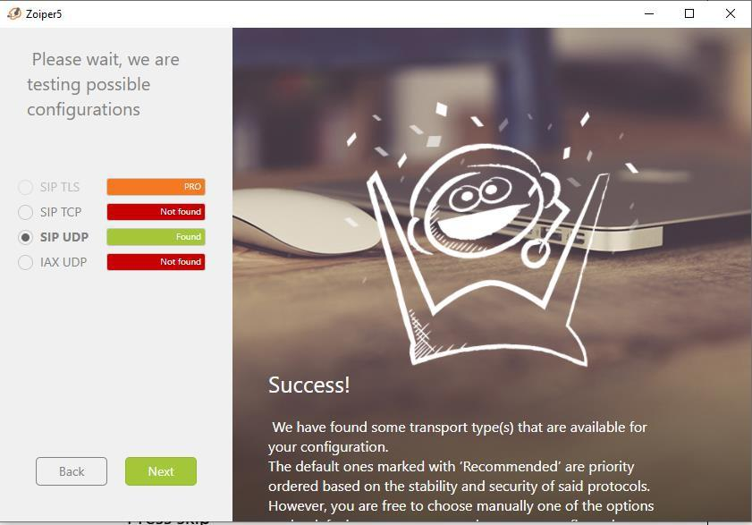
- The SIP UDP should be in green colour, found. Click next

[Type here]
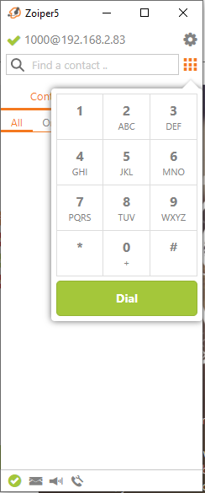
- The green arrow means your extension has properly been assigned to the softphone.

